{William Crenshaw}
{Travis Evans}
{Project 16 01: The intro story of Chikyuu!}

The year is 13284, and something epic as hell is about to happen... Somewhere in a mountainous area, on the main island of Japan, is a little shelter time capsule and it's only resident is about to be reactivated! Boing boing, went the character's ahoge antenna, as it picks up a remote boot signal via radio waves from the creator from far away. The character's name is Chikyuu a very advanced 1st century (2080s). Built by your's truly! She has long electric blue hair and wears a massive white shirt with extreamly long sleeves (one sholder is exposed too). As her POST finishes and her BIOS ROM is loaded. she is so confused! “Where am I? Who am I? What am I? What time it is?”. She has lost all memories but not her intelligence. Damn CMOS battery fried a very long time ago. She is right next to a retro PC that runs FreeDOS.

Ecstatic to see her favorite software, she rushes to the PC and begins to create a tether between herself and the machine. After a few seconds, however, she stops, realizing that the old machine cannot sense her telepathic input. Observing the archaic keyboard, the bulkiness of the monitor, and the insides contain a i80486DX@33mhz with ISA buses, she concludes that the PC was built in the early 1990s. “What am I going to do now?” she cried out. “I don’t know how to use a keyboard! That technology is almost a hundred years old!” Applying what she remembers from old videos tapes, books, and manuals lying around the facility all well preserved, she gains a rudimentary understanding of how to use the keyboard and mouse to work with the old school user interfaces and barely got the machine booting again, but she knows that she would need a lot more than that to use the FreeDOS software. “Oh! A splash screen! I was not expecting that.”, she said as turns away from the PC and starts thinking about her priorities. “How long have I been deactivated?” she asks herself, remembering that old computers running clock.com from 1998 displayed the date in the top right corner of the screen. She turns back to the computer and is horrified by what she sees. “January 26, 13284? That can’t be right! It feels like I was asleep for only a few hours!” After a few minutes of panicking, she launched the web browser arachne that she learned about and a flashing icon on the screen catches her eye. When she clicks the icon, she discovers that she has one notification: a single message, addressed specifically to her, received just a few minutes ago.

The little message says, “Dear Chikyuu (地球) (Sol Child #1), I turned on the facility's power from it's little fusion reactors, via radio~. Then I check the Internet connection, by doing a remote ping~. After that, I did a remote boot to your internal fusion reactor, via radio also~. Anyway I predicted you are wondering what happened? No, nobody set up us the bomb! You whe”. “Nani?” she said, in confusion. “I think the connection dropped!” She checked and it did! She sighed, then the rest of the text came up but a huge chunk of text was missing. “t has changed. Oh, and please respect the 100% biological humans! Your POST messages and sensor indicate your perfectly fine. I told one of those crazy delivery mail androids, who love to go fast and deliver shit, to leave a package at the main door for you not long ago! (I know! They are strange but helpful!!) It contains a custom portal pocket module for you. It can store items in a room you specify in this facility! You use it by reaching down your side while the pp is selected in your hud, and it should display the items you specified in that room. Then you pick the item and IT APPEARS. Fucking science is beautiful isn't it? To put it away you just do the reverse of that. Yes you can take this IBM PC clone out and freak people out!w Meet me at the Vostok Research Station site area. Yes in Antarctica. But you can take your time! I am in no hurry! Feel free to explore! You can contact me via radio waves! I now can see your vision and sensors! Excellent! I will not remote control you unless you ask me to! I will send messages to your internal message box!

With lots of fucking love,
yo mama!” “性交は何！？”, she said in extreme shock, “All the way to Antarctica?! CRAZY!!!!” Then she felt a very strong cold presence in the room, and the power switch was turned off on her retro PC! She freaked out! Ran to the main entrance area! Opened the main door which is quite heavy but she we so frightened that she pushed the door so hard that the mechanisms that open the door automatically did no work at all! It was covered in dense vines too! And she ran as fast as possible out the door, but immediately tripped on the package outside. “イタイ！”, she exclaimed! Fortunately she is fine and the ???? only wanted to do that prank. She gets up, looks around, and see a little field in a dense forest surrounds he little facility and the field. Then she detected some talking noises from near by. “?! Hmm? People are near me?”, she said. Then she remembered about the package. “I better go set this thing up.~”, she cheerfully said.

She opened the package, finding the portal module nestled in a large wad of bubble wrap. After popping the bubble wrap for several hours, her attention turned back to the module, which had a large red button on the front. When she pressed the button, the module expanded outward and formed a robotic glove around her arm. It looked like THE POWER GLOVE! With renewed vigor, she used the bionic glove to amplify her bubble wrap popping skills, reaching a speed of over 1 bubble per second. After several days, she grew tired of popping the bubble wrap and pressed a button on the back of the glove. A holographic monitor materialized in front of her, containing the java source code which makes the glove work. She ran the program, making sure to save and compile first, and a small window appeared in front of her, asking her to input the X, Y, and Z coordinates of the room from which she wanted to take items. After entering 911, 8675309, and 90210, a small portal appeared in front of her. Sticking her head in, she notices that any items in the room are out of her reach. She pulls her head out of the portal and reruns the program, entering 1000, 1000, and 1000. She enters the newly created portal and notices that she ended up in the same exact place. Baffled, she looks through the source code to search for the cause of the problem. After a few minutes of searching, she finds that entering invalid coordinates causes the portal to open in the default location, much like entering a zero for a denominator in the Fraction class defaults its value to one. Analyzing the bounds of valid coordinates, she computes what she believes to be correct coordinates. Entering them into the window, she closes her eyes and jumps into the portal with anticipation. Opening her eyes, she sees that the portal had dropped her into the gaping maw of an active volcano! As she falls to her death, she realizes that there is only one thing that can save her.

“POWER GLOVE!”
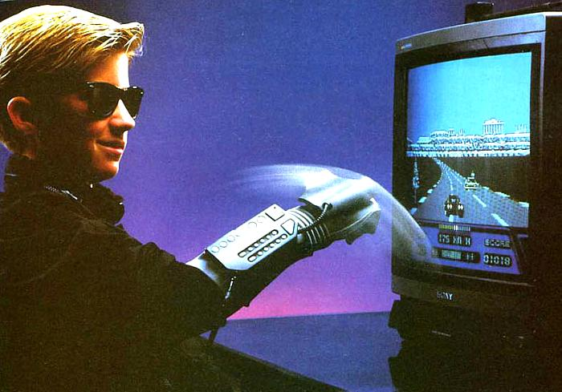
, she yelled as she used it to open a pig portal to the default location. She did not realize the coordinates are actually based on latitude, longitude and altitude. She is scared so badly that her nuclear waste system activated and she … a shiny soft metal brick. After a short period she started to message her mom. “I nearly fell into a volcano you jerk!”, she wrote as she then sends the message via radio waves. “Yeah.... I saw.... and I forgot to tell you the coordinates and altitude.”, her mom wrote back. “If you mess with the code too much I can theoretically make a fucking time machine, but you are absolutely forbidden to go to the past! Because, JUST WATCH BACK TO THE FUTURE AND YOU GET THE IDEA!”, she said sternly. “I do not remember your position at all. Thank fully the glove has a super accurate GPS system. I can use a low orbit ion cannon to zap yo..... Did I say that out loud? wwww Anyway I will send you the exact coordinates if you do not mind telling me them! Just poke me and I will map the room yo~.”, she said. “Ok!”, said Chikyuu. So after they set up the room via going to the corners and placing the glove on the corners of the room. The mom messaged her, “That should do it! I think your all set and the default configurations are now over written with your configuration! Go ahead test it out!” With out hesitant Chikyuu stepped out side the facility and used the power glove! She was able to open a portal into that room and she was able to stick her head in there and find she can reach the things! “わい～！”, She exclaimed in joy and excitement! She removed her head from the portal and back to herself. She is very curious about the noises in the back ground. She heads over there to the source of the sounds, and it turns out that it is actually a human village! I have to stop the story here because it is very very long as hell and It will be continued when I get the tile engine to do bloody tiles

